**SYNOPSIS**

**Project Team No**: 23SOCU1178

**Register No: Name:**

**1.**124014017Iraianban S

**2.**124014043 Sanjai Praveen S

**3.**124014055 Swetha S

**Project Title**: Detection of Damage on Steel Manufacturing

**Name of the Guide:** N. Senthil Anand , Assistant Professor –II , Dept of mca/soc

**Abstract:** The traditional method used for corrosion damage assessment is visual inspection which is time-consuming for vast areas, impossible for inaccessible areas and subjective for nonexperts . A numerical framework for screening of uniform corrosion on steel structures . A fully automated, fast and objective screening for corrosion. Image analysis based on the roughness and color analysis, and a performance metric. This algorithm quantifies and combines two visual aspects – roughness and color – in order to locate the corroded area in a given image. For the roughness analysis, the uniformity metric calculated from the gray level co-occurrence matrix is considered. For the color analysis, the histogram of corrosion representative colors extracted from a data-set in HSV color space is used. Our findings show that the developed algorithm can efficiently locate corroded areas.

**Specific Contribution:**

* Combination of Roughness and Color Analysis

**Specific Learning:**

* Automated Image Processing

**Technical Limitation & Ethical Challenges faced:**

* Difficult in finding Dataset, Difficult to evaluate Performance Metrics

***Keywords :*** *Visual Inspection , Roughness Analysis , Color Analysis*

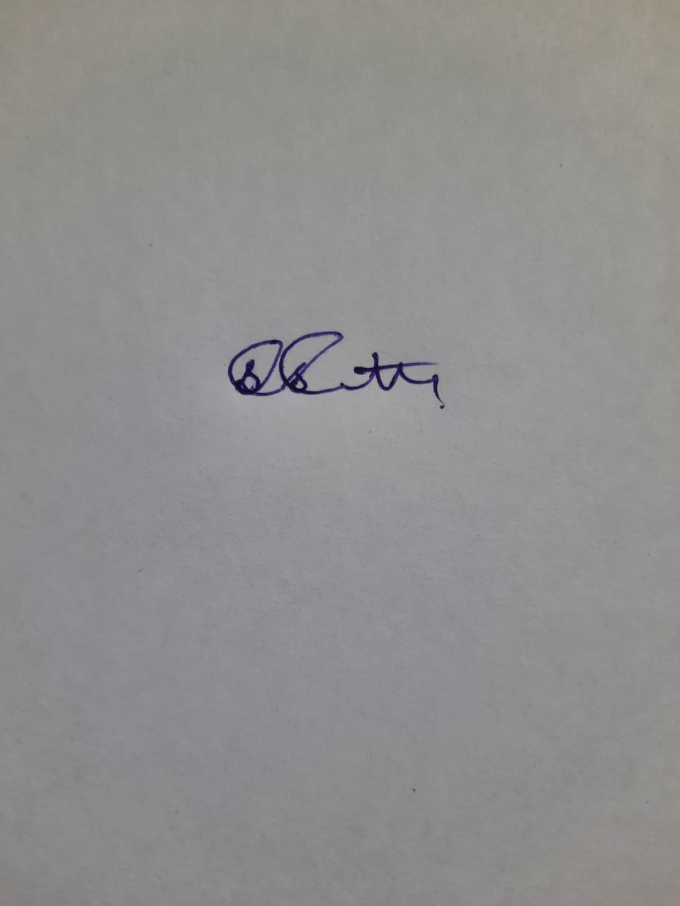**Name & Signature of the Student Signature of Guide**

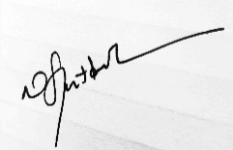Swetha.S

**Date:10-05-2023**